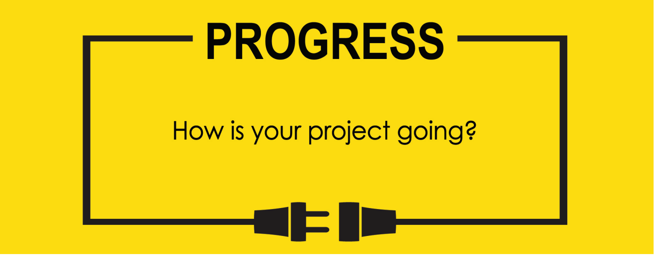

**Name: Zach Wilcox**

**Project Title: GreenBox**

**Previous Goals**

What were your three goals from last week? Were you able to complete them? If so, select Completed. If not, select the level of completion and explain in the Notes section why the goal was not completed, what still remains to be done, and when you expect to finish work on the goal.

Goal #1 from last week: Finish box build

**Status:** _____Completed ___x__Partially Completed _____No Progress

**Notes:**

Assembly has continued, the hinges are attached and many of the smaller pieces have been shaped. The adhesive purchased was the wrong type so the assembly of the larger portions will have to wait until the correct adhesive arrives.

Goal #2 from last week: Code needed timers

**Status:** _____Completed __x___Partially Completed _____No Progress

**Notes:**

Marked partially complete, though I do tentatively think it is completed. More testing is required before I can confidently say whether the timers are all finished.

Goal #3 from last week: get knob/potentiometers and assemble those circuits for use in GPIO control code

**Status:** _____Completed __x___Partially Completed _____No Progress

**Notes:**

The knobs/potentiometers that will be used on the box have not yet arrived, though I was able to test some of the circuitry using different types of potentiometers that I already had on hand. The code has some progress, but no single portion is completed.

The cooling unit came in and so I was able to start working on the assembly to hold it in place and the power circuit for it. The parts I already had were not quite robust enough to power it properly.

**Next Three Goals**

Choose three subtasks from your Gantt chart and use them to form goals that you plan to complete this week. In the text box beneath each goal, give details about what you plan to accomplish. Include details such as what materials are needed, how many hours each day you plan to devote to the task, and so on.

NOTE: THESE ARE INDIVIDUAL GOALS THAT YOU PLAN TO ACCOMPLISH. THESE ARE NOT TEAM GOALS.

**Goal #1:** Finish box build

**Goal #2:** Power the cooling unit/finish unit housing

**Goal #3:** get knob/potentiometers and assemble those circuits for use in GPIO control code

Some of the code for the timers

Previous Gantt chart

Updated Gantt chart. Software development has been extended.

